# **Task#1**

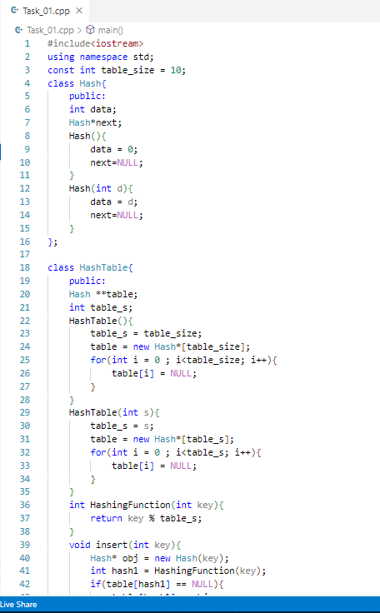

## **Output**

# **Task#2**

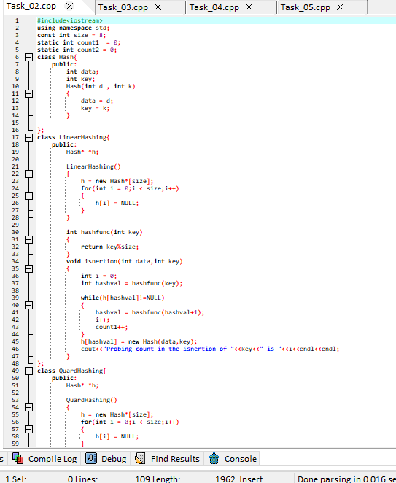

## **Output**

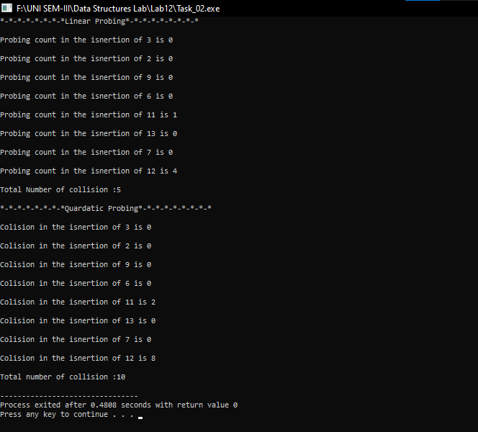

# **Task#3**

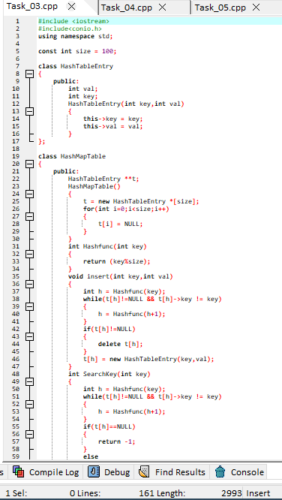

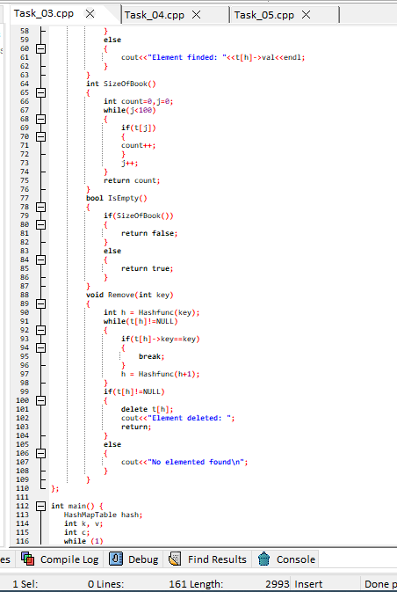

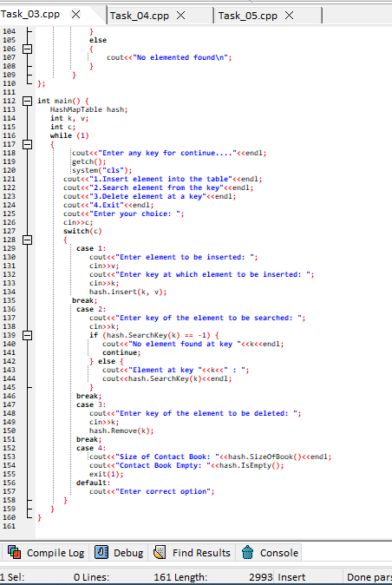

## **Output**

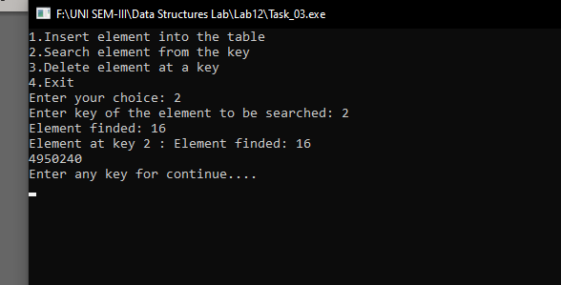

# **Task#4**

## **Output**

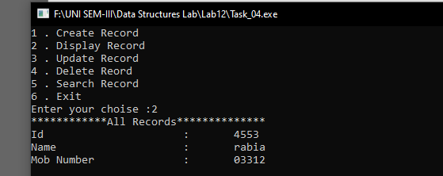

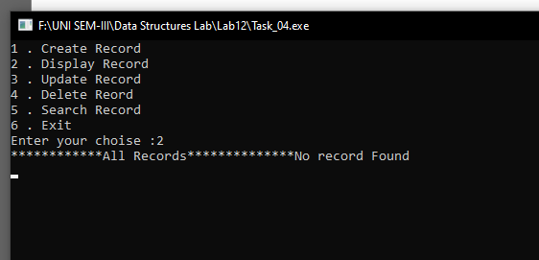

# **Task#5**

## **Output**



